

Kindergarten News

Sight Words Review

he



Upcoming events
December 3rd –7th – Ring a Bell Campaign for Youth Mental Health
December 4th – Last day to buy tickets for the students’ Christmas Dinner!
December 5th – Wear a Santa hat, Elf hat or reindeer antlers or any festive head wear for $1 (Fundraiser for the Fredericton Community Kitchen)
December 11th – Christmas Concert (1st Show – 9:00 am/2nd Show – 11:00 am)
December 12th – Wear a festive sweater for $1 (Fundraiser for the Fredericton Community Kitchen)
December 13th – Christmas Dinner for students ($5.75)





Notes from the teacher:
Continue working on building independence in your child’s ability to put on and take off their winter outer wear. Thank you! ☺
We now have a Librarian! Mrs. Storey started last Thursday. We are all excited!
Please continue to practice letter recognition & sounds, sight words and counting regularly.
If you have any questions or concerns please feel free to contact me at rolly.sidik@nbed.nb.ca, or call the school, (506) 453-5438.


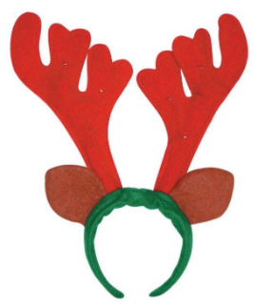

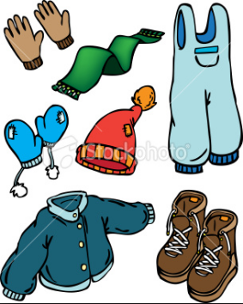

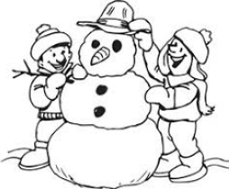

What we are learning this week:

Reading | Writing | Math | You and Your World
- Letters: V, Y  - Sight Word: he  - Strategy: Lips the Fish – Get your mouth ready. Say the first sound.  - Review letters: s, a, t, i, p, n, c/k, e, h, r, m, d, g, o, u, l, f, b, j, w | - Writing words that match their drawings  - Practice proper letter formations for: v, y, j, w, f, b, u, l, o, p, n, t, i, s, a, c/k, e, h, r, m, d, g, o  - Practice reading, writing and spelling sight words  - Practice writing their names | - Say the number sequence 0-10.  - Represent and describe numbers  - Subitizing 1-5 objects  - Relate a numeral to its quantity 6 to 10  - Identify, create and reproduce patterns with 3 elements in the core | - Recognize and respect the various traditions, rituals and celebrations of families  - W.I.T.S. Strategy  - Habit 2: Begin with the end in mind. (I plan ahead and set goals. I do things that have meaning and make a difference. I am an important part of my classroom.)

